Vestige International
ONLY
$39.99
School Spirit Letter Jacket
Order Form

Name: ________________________________________ Telephone: ______________________
Address: _____________________________________________Homeroom: ________________
QTY: ______ Size:___________ School:________________________________________
Parent/Guardian Name: ________________________________________ Jacket Color: ______________
Personalization Name: ____________________________________ Style: Ladies Regular
Activity: ______________________________________________________________________
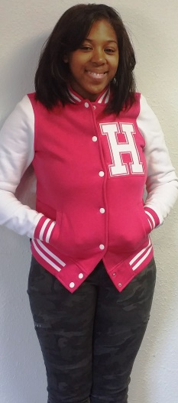
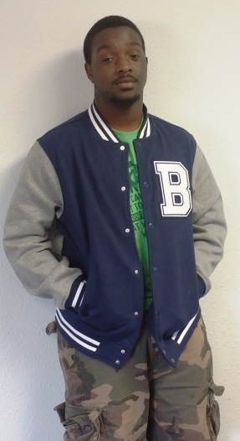
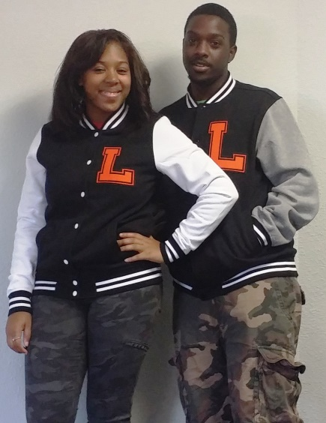
New! SPORT TEK FLEECE LETTERMAN JACKETS
It’s your traditional letterman jacket but in warm comfortable fleece for a winning look
- -Rib Knit Matching Collar
- -Matching Cuffs and Waist Band
- -Snap Front Closure
- -Front Slash Pockets

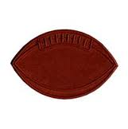
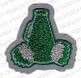

Total Amount: $________________
Amt. Paid: $ ___________________
Balance Due: $_________________

Suggested Retail Price $59.99
***********Special Discount $39.99*********
($20.00 Savings)
Personalization $10.00

Vestige International
509 N. Hampton Rd Ste. 203
Desoto, TX 75115
(972)-230-5399
(972)-230-1942
sales@vestigeinternational.com
www.vestigeinternational.com

We accept cash and checks
Please Make Check payable to Vestige International
$35 return check fee
PREPAYMENT IS REQUIRED ON ALL ORDERS!!!
All sales are final with delivery
DON’T FORGET . . .
To personalize your jacket with your name and your extracurricular activities:
Signature Date

