Lesson 3 Reteach

Slope and Similar Triangles

Recall that the slope of a line is the ratio of the rise to the run. You can use properties of similar triangles to show the ratios of the rise to the run for each right triangle are equal.

Example
Write a proportion comparing the rise to the run for
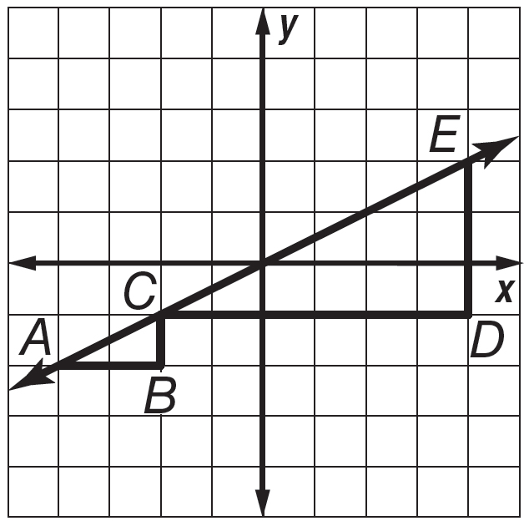
each of the similar slope triangles shown at the right.
Then determine the numeric value.

$\frac{CB}{ED}$ = $\frac{BA}{DC}$ Corresponding sides of similar
triangles are proportional.

CB • DC = ED • BA Find the cross products.

$\frac{CB •DC}{BA • DC}$ = $\frac{ED • BA}{BA • DC}$ Division Property of Equality

$\frac{CB}{BA}$ = $\frac{ED}{DC}$ Simplify.

$\frac{1}{2}$ = $\frac{3}{6}$ CB = 1, BA = 2, ED = 3, DC = 6

So, $\frac{CB}{BA}$ = $\frac{ED}{DC}$, or $\frac{1}{2}$ = $\frac{3}{6}$.

Exercises
1. Graph ∆XYZ with vertices X(–3, 5), 2. Graph ∆ABE with vertices A(-4, -3),
Y(–3, 3), and Z(0, 3) and ∆ZLP with B(0, 0), and E(0, -3) and ∆ACD with
vertices Z(0, 3), L(0, –1), and P(6, –1). vertices A(–4, –3), C(4, 3), and D(4, –3).
Then write a proportion comparing the Then write a proportion comparing the
rise to the run for each of the similar rise to the run for each of the similar
slope triangles and determine the numeric slope triangles and determine the numeric
value. value.
