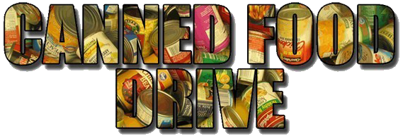

ANYONE CAN GIVE TO HELP OUR COMMUNITY! JUST BRING YOUR CANNED FOOD ITEMS TO THE LIBRARY(for book fees) OR Give it to your reading teacher to help your reading class win.

**Library FEE$ and Reading Class Breakfast**

**Nov. 30th thru Dec. 11th**

REACH OUT AND HELP OTHERS IN OUR COMMUNITY!

**The Student Council Crew, Diamonds & Pearls, and the West Middle School library are working together to offer you a chance to help our community and get your overdue library fees paid! Just come by the library and give our librarian 1 canned food item for each dollar you owe in overdue fees!**

***If you don’t owe fees! Reading Class Contest*   
 Reading Classrooms who collect the most canned goods will win donuts and juice from Mrs. Finley and the Stu. Co. Crew!**

**FooD**

**ALL DONATIONS WILL BE DELIVERED TO OUR LOCAL FOOD PANTRY.**

**FoR**