Relations – Functions – Linear Equations

Function Table
$$y=2x+1$$
x | $$2x+1$$ | y | (x, y)
$$-1$$ | $$2\left(-1\right)+1$$ | $$-1$$ | $$(-1,-1)$$
0 | $$2\left(0\right)+1$$ | 1 | $$(0, 1)$$
1 | $$2\left(1\right)+1$$ | 3 | $$(1, 3)$$
2 | $$2\left(2\right)+1$$ | 5 | $$(2, 5)$$

Domain Range
$\left\{-1, 0, 1, 2\right\}$ $\left\{-1, 1, 3, 5\right\}$

Mapping
x |  | y
$-1$ |  | $$-1$$
0 |  | 1
1 |  | 3
2 |  | 5

If a domain (x) value repeats, it is not a function.
+1
Slope
+1
$\left(x_{1}, y_{1}\right)(x_{2}, y_{2})$ $\frac{rise}{run}$
+1
Ex. $(0, 1)(1, 3)$
$m=\frac{y_{2}-y_{1}}{x_{2}-x_{1}}=\frac{3-1}{1-0}=\frac{2}{1}$ $\frac{y}{x}$

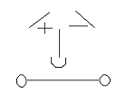
Slope Guy

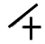
Positive Slope
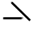
Negative Slope
Undefined $y=\frac{2}{0}x$

Zero Slope $y=\frac{0}{2}x$Constant Rate of Change

x | $$2x+1$$ | y
$-1$ | $$2\left(-1\right)+1$$ | $-1$  +2
0 | $$2\left(0\right)+1$$ | 1  +2
1 | $$2\left(1\right)+1$$ | 3  +2
2 | $$2\left(2\right)+1$$ | 5

- As x increases by +1, y increases by +2.
- The constant rate of change is $\frac{y}{x}=\frac{2}{1}$ .
- A constant rate of change is the same as the slope,
Point-Slope Form
$y-y_{1}=m\left(x-x_{1}\right)$

Y-coordinate Slope X-coordinate
Ex. $\left(1, 3\right) and m=\frac{2}{1} or 2$
$$y-3=2\left(x-1\right)$$
$$y-3=2x-2$$
$$y=2x+1$$

Slope-Intercept Form
$y=mx+b$

Slope Y-Intercept
$\frac{y}{x}$ (the point on the y-axis)

Standard Form
$Ax+By=C$

X-Intercept Y-Intercept

To graph the equation, let $y = 0$ and
solve for$x$. Then let$x = 0$ and solve
for $y$. The$x$ and $y$ solution will be
the $x$- and $y$- Intercept on the graph.

Ex. $-4x+8y=16 y=0$
$$-4x+8(0)=16$$
$$-4x=16$$
$x=-4$ $(-4, 0)$

Ex. $-4x+8y=16 x=0$
$$-4\left(0\right)+8y=16$$
$$8y=16$$
$y=2$ $(0, 2)$

Graph using Slope-Intercept
$y=-2x-3$
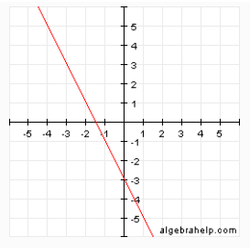

Y-Intercept
$$m=-\frac{2}{1}$$

Graph Linear Equation
$$-4x+8y=16$$

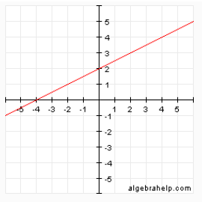

$$(0, 2)$$
$$(-4, 0)$$

