Graphic Organizer  - Neat/well written  - Utilize color  - Complete sentences  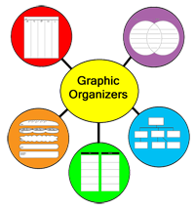  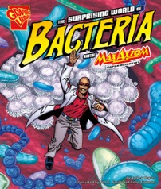  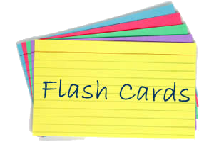  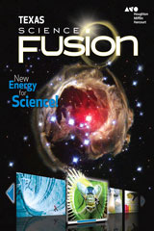  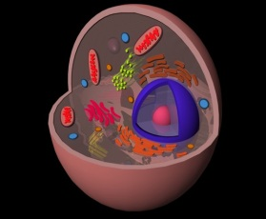  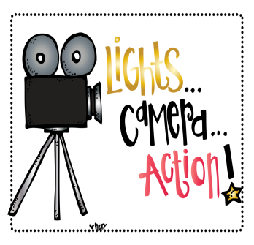  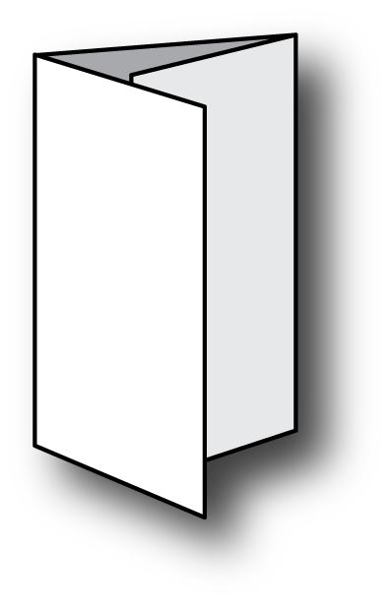  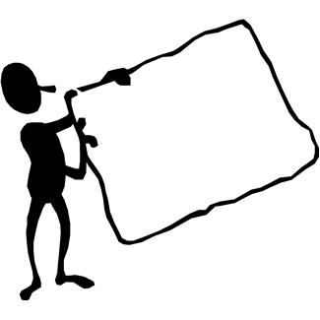  choice board  10 points | Poster  - Must include graphics  - Colored/decorated  - Neat  50 points | comic picture book  - 10 frames  - Colored/decorated  - Neat  50 points | Flash cards  - Neat/well written  - Utilize color  - Complete definitions(10)  10 points | 3-d model  - Original  - Constructed by you  - Neat/decorated  80 points
Story analogy  - Rough draft or outline  - 1 typed page  - 12pt T.N.R dbl spaced  50 points | Textbook lesson  - Legible  - Complete sentences  - Correct answers  20 points | Song/rap  - Must have music  - Typed lyrics  - 2-5 min. long  80 points | Skit  - 3-5 min. long  - Typed script  - 2- 4 per group  80 points | Foldable  - Colored/decorated  - Neat/well written  - Must include graphics  20 points

