Lesson 2 Reteach

Volume of Cones

A cone is a three-dimensional shape with one circular base.
The volume V of a cone with radius r is one third the area of the base B times the height h.
V = $\frac{1}{3}$Bh or V = $\frac{1}{3}$πr²h

Example
Determine the volume of the cone. Round to the nearest tenth.
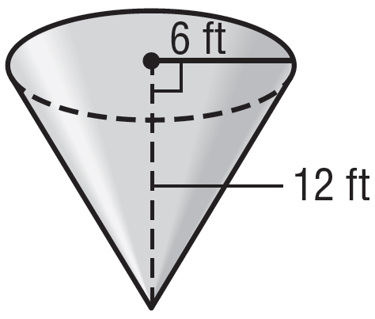

V = $\frac{1}{3}$πr²h Volume of a cone
V = $\frac{1}{3}$(π • 6² • 12) r = 6 and h = 12
V ≈ 452.4 Simplify.
The volume is about 452.4 cubic feet.

Exercises
Determine the volume of each cone. Round to the nearest tenth.

1. 2. 3.
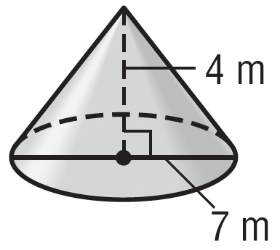
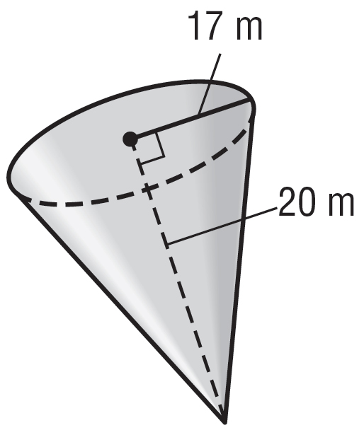
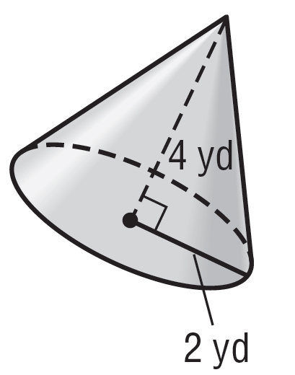

4. 5. 6.
