Lesson 3 Reteach

Volume of Spheres

A sphere is a set of all points in space that are a given distance from a given point.
The volume V of a sphere with radius r is four thirds the product of π and the cube of the radius r.
V = $\frac{4}{3}$πr³.

Example
Determine the volume of the sphere. Round to the nearest tenth.
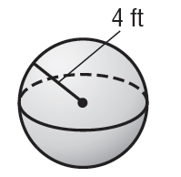
V = $\frac{4}{3}$πr³ Volume of a sphere
V = $\frac{4}{3}$ (π • 4³) r = 4
V ≈ 268.1 Simplify. Use a calculator.
The volume is about 268.1 cubic feet.

Exercises
Determine the volume of each sphere. Round to the nearest tenth.

1. 2. 3.
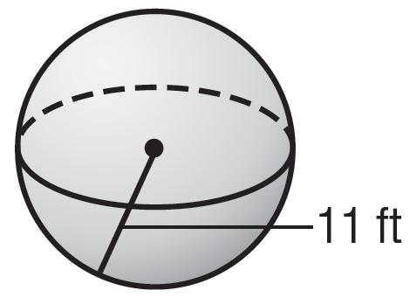
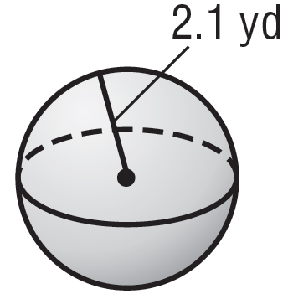
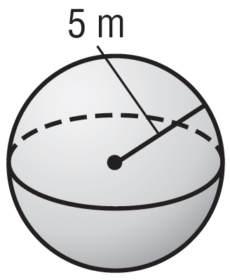

4. 5. 6.
