War of 1812 (American Revolution Part II)/ American Economy Notes
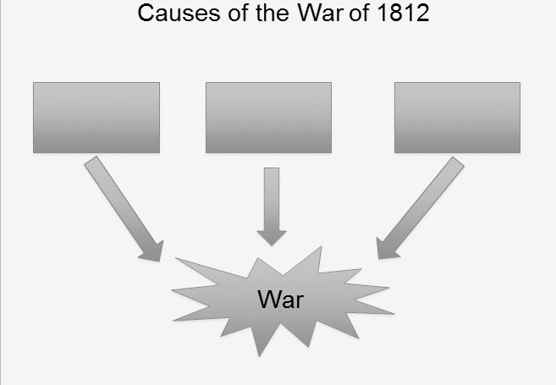

Who was the 4th President of the United States and Party affiliation?
Events of the War of 1812

What Treaty ended the War of 1812?

Who was the HERO in the Battle of New Orleans?
3 Effects of the War of 1812?
1.

2.

3.
Explain what is a CANAL is?

James Monroe “Era of Good and Bad Feelings”
“Time of Prosperity and Pride!”

Give examples of the Prosperity the United States witnessed?
1.
2.
3.
The provisions of the Missouri Compromise 1820:
1.
2.
Three points of the Monroe Doctrine
1.

2.

3.

What do these political cartoons suggest?
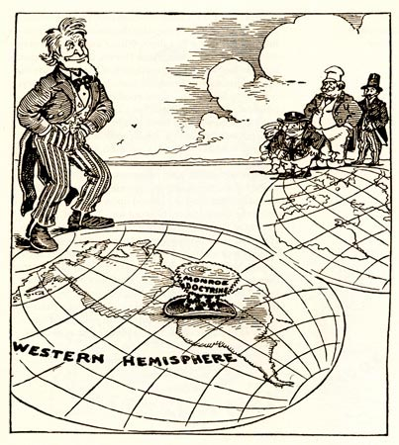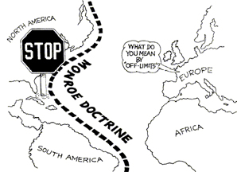
What was Monroe’s Presidential policy on Latin American Countries?

Explain the impact of the Monroe Doctrine on the U.S. foreign policies?

